Radiated Emission Test Report

Contents

1. Test lab facility 2

Test Site: 2

Facility name: 2

Facility address: 2

Facility site description: 2

Test Standards 2

EMC Directive 2014/30/EU 2

Test Equipment: 2

Environmental conditions: 2

Test Operator and Date: 2

2. Product Information 3

3. EUT setup 3

Photograph of EUT: 3

4. Test Result 3

5. Summary 3

# Test lab facility

## Test Site:

Facility name: Keysight Technology, Technology Order Fulfillment, Colorado Springs Hardware Test Center.

Facility address: 1900 Garden of the Gods Rd, Colorado Springs, CO. 80907

Facility site description:

3 Meter Semi-echoic chamber.

Note: *The radiated RF disturbance measurements were performed on an alternate test site of a semi–anechoic chamber at a 3 m distance. The 3 m test distance on an alternate test site is allowed because the EUT met the definition of small equipment in clause 3.10 and per clause 8.4 of CISPR 11:2009+A1:2010. The alternate test site semi–anechoic chamber meets the volumetric NSA validation requirements in CISPR 16–1–4 for the ±–4 dB from theoretical at all positions and antenna polarizations in the test volume*. *The limit for 10 meter site is adjusted by 10dB to fit 3 meter site.*

## Test Standards

### EMC Directive 2014/30/EU

IEC 61326-1:2012 / EN 61326-1:2013 (Basic) Radiated Emission Reference Standards:

CISPR 11:2009+A1:2010 / EN 55011:2009+A1:2010 Group 1 Class A. The products were tested in a typical configuration with Keysight Technologies test systems. This product is intended for use in a basic electromagnetic environment.

## Test Equipment:

|  |  |
| --- | --- |
| MXE Receiver Address | USB0::0x0957::0x0f0b::MY51210168::0::INSTR |
| Turn Table Address | gpib8 |
| Antenna Address | gpib9 |
| MXE Model S/N | MXE N9038A MY51210168 |
| MXE Calibration date | 12/8/2015 |
| Turntable SN | ETS Lindrgen Model 2090 MY70235245 |
| Turn Table calibration date | 12/1/2015 |
| Antenna SN | ETS Lindrgen Model 3142E |
| Antenna calibration date | 12/1/2015 |
| System loss calibration date | 4/1/2016 |
| NSA calibration date | 12/1/2015 |
| Test Standard | CISPER 11 Group 1 Class A RE |
| Test Site | Colorado Springs TOF Hardware Test Center 3 Meter anechoic chamber |
| Test Voltage | 110V |

## Environmental conditions:

Temperature: 72°F; Humidity :50 RH

Note: There will be no effect to the result due to changes in mains voltage or frequency.

## Test Operator and Date:

Operator: Clifford; Report generated at: Mar.22,2017 3:16:12 PM

# Product Information

|  |  |
| --- | --- |
| Product Name: | Canvas |
| Product Model: | Canvas Cart |
| Product SN: | No. 15 |
| Project Stage: | Beta 1 |
| Deliver date of the test samples: | 3/22/2017 |
| DUT power: | Powered by BaTTERY |
| Auxiliary equipment list: | n/a |
| Model numbers covered by the test: | N/a |
| .-Hardware Difference | N/a |
| .-Software/firmware difference: | N/a |
| .-Cosmetic difference: | NA |
| Test Configuration | NO Cover, No Camera Lan, Camera is powered on but wrapped with alumn foil on one set of camera |

# EUT setup

## Photograph of EUT:

# Test Result

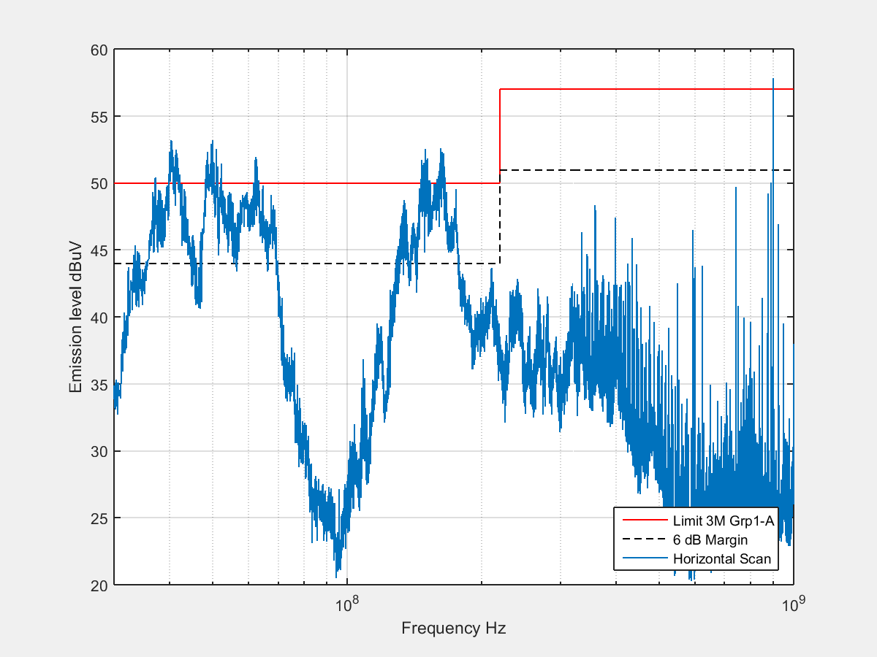

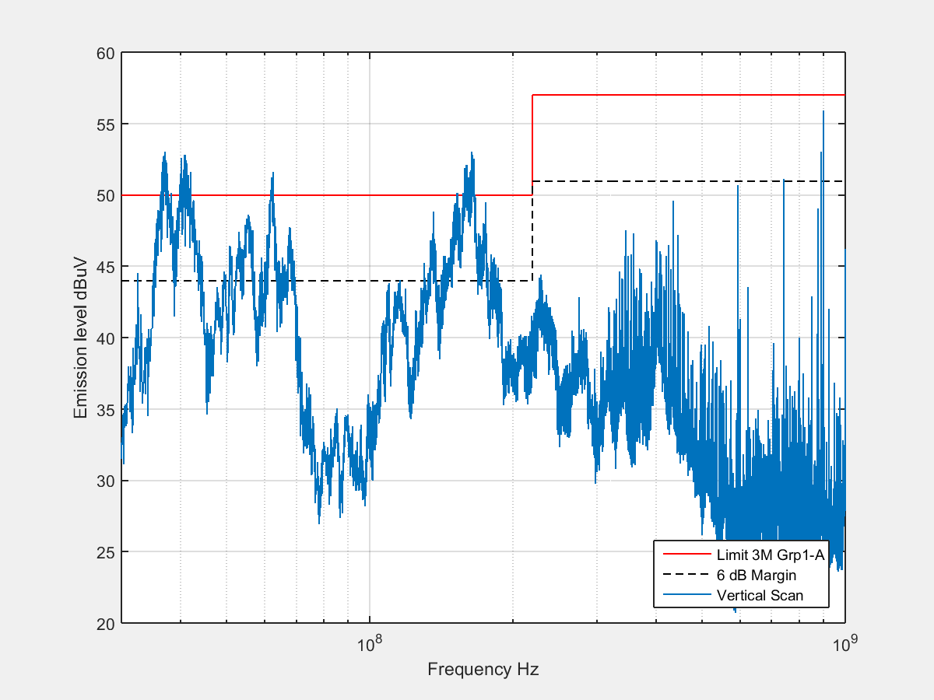

# Summary

The unit Passed the Radiated Emission Test in Horizontal polarization!

The unit passed the Radiated Emission Test in Vertical polarization!